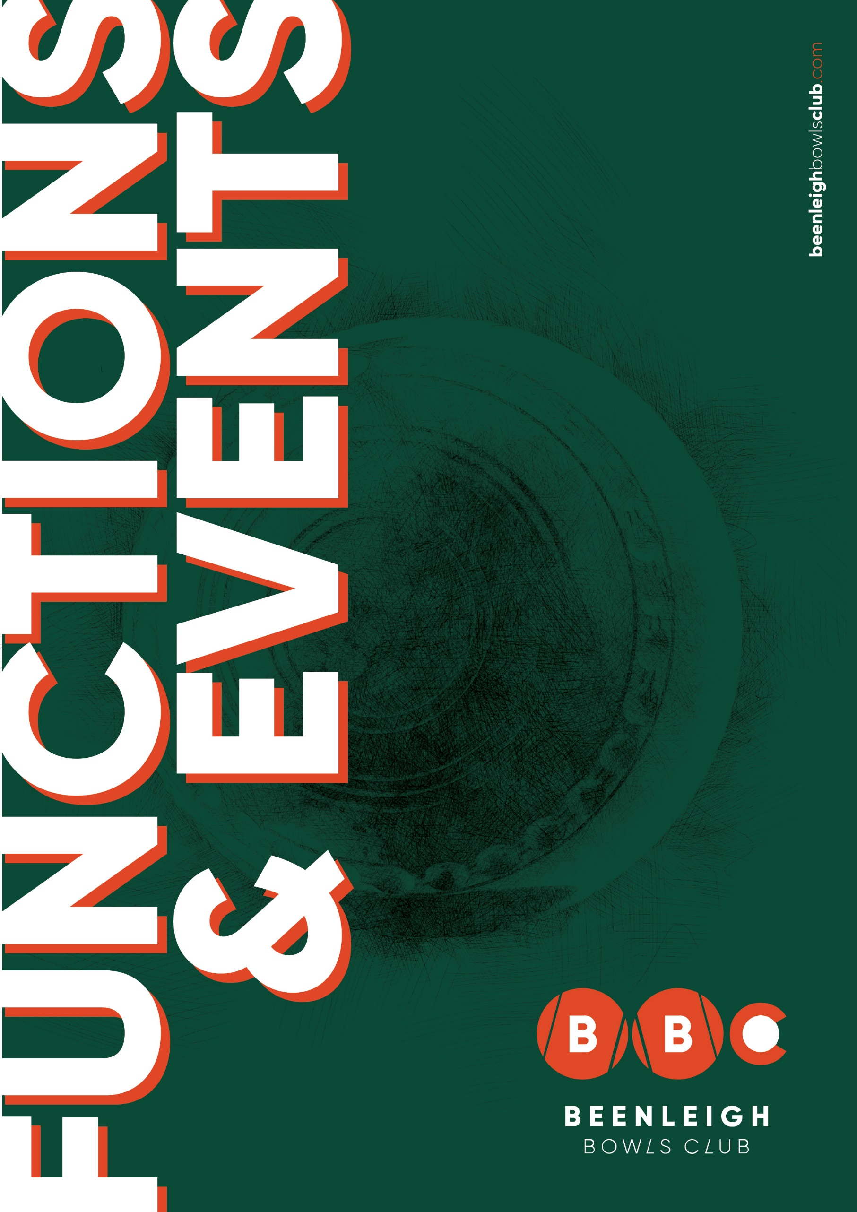
Welcome to the Beenleigh Bowls and Recreation Club.

Our team would like to take this time to thank you for considering us for your next event. With over two decades of serving the community through various events and functions, our team are more than ready to build on that legacy and make your day one to remember!
Our function and event packages are designed to take the stress out of planning, so you can sit back relax and enjoy the atmosphere and occasion.
We can cater for every event from casual barefoot bowls to family event or party, including boardroom or theatre style product launches and meetings to suit all budgets.
All supported by an enthusiastic team of staff to ensure a smooth and wonderful journey.
We can cater for all kinds of requests, please contact our functions coordinator to discuss and we will do our best to accommodate your specific requirements.
Thank you once again for choosing us!

11 Hanover Street
Beenleigh 4207
07 3287 2208
events@beenleighbowlsClub.com

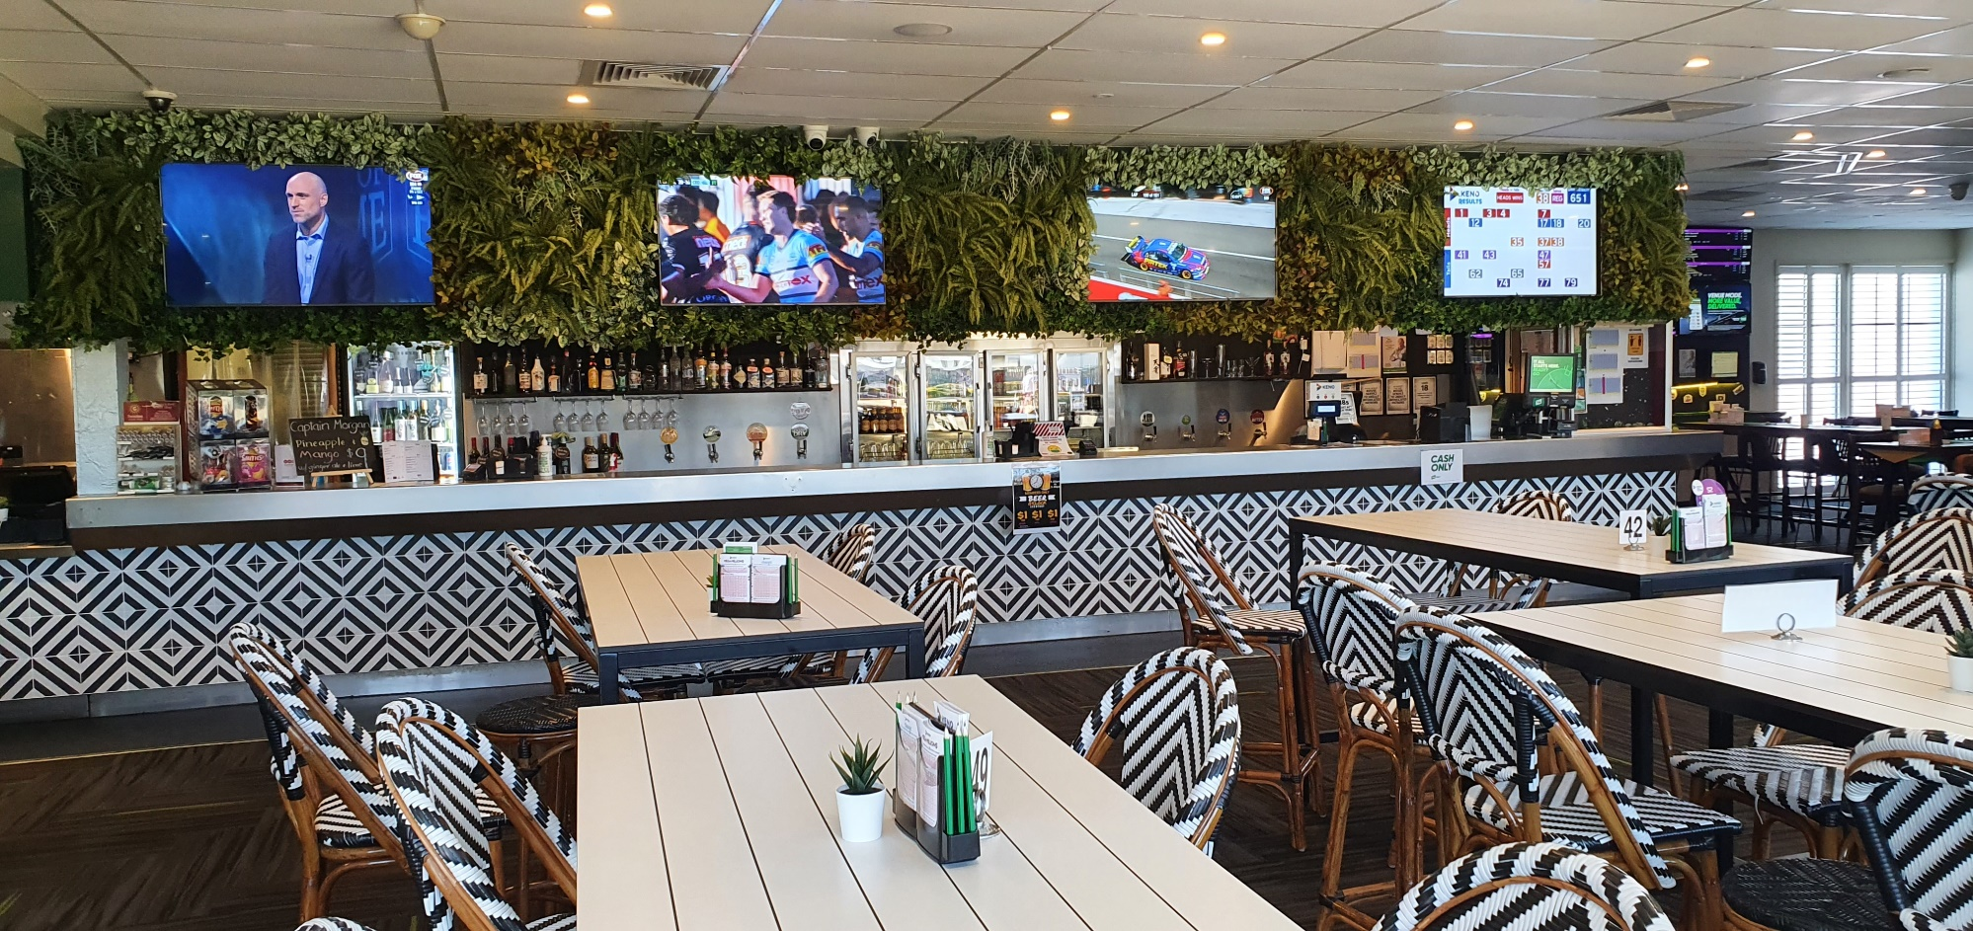

Function Areas

Chandelier Room
The Chandelier Room is ideal for all types of functions. Consisting of a full private bar, kitchen, balcony, and dance floor, microphone, white board, WIFI available upon request and big screen TV with HDMI cable. We can cater cocktail style or seated up to 100pax. Room hire includes basic set up (complex set up will incur a fee), staff for your event and cleaners for after your event $750. Decorations & table cloths must be organised on your own accord and cleaned up the night of your event.
*Note. No confetti to be used in the Club, or you will be charged a cleaning fee.

Hire Price List
- Cake Service (cut up and served with serviettes at preferred time) $50.
- Tea/coffee station served with milk $50

Barefoot Bowls
Great fun for all ages. Each rink holds up to 8 players with 7 rinks per green, 90-minute sessions with all equipment and a 10min introductory lesson provided. With the below catering options to choose from. Available outside of bowls calendar events times and by appointment only. Bowls is $10 per person.

**Please note room hire payment will secure your booking date. Further, all arrangements and payments must be finalized 14 days prior to the event.
**Cancelations must be made 2 weeks prior for chandelier room bookings to be eligible for a refund of monies paid for event bookings.
** No refunds will be given for changes to numbers for bowls events or food within 7 days of booking.
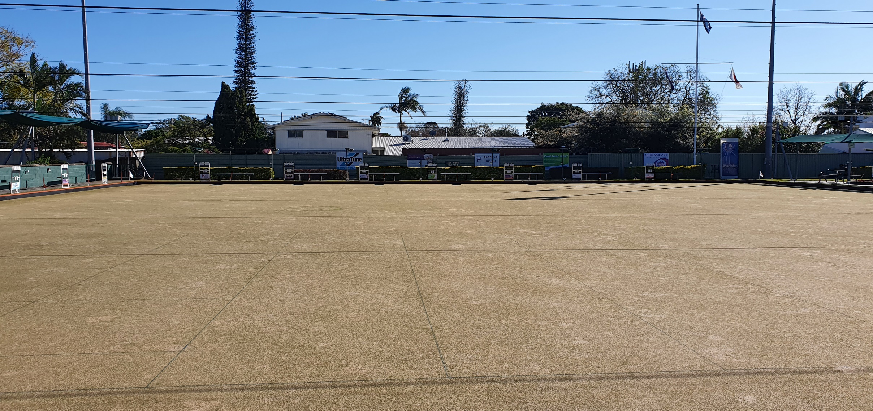
Catering Options

Roast Dinner
(Minimum of 30 people)

Roast Dinner Plate
$33pp or $15 per child up to the age of 11.
- Your roast meat carved by our chef. Your choice of Roast Chicken or Seeded Mustard Roast Beef
- Golden roast potatoes, carrots & pumpkin
- Cauliflower & broccoli baked in a white cheese sauce
- Gravy (GF) & dinner roll with butter

Dessert
(extra $6pp – alternate drop
- Pavlova with fresh fruit and cream & Apple Crumble with Ice-Cream

Christmas Roast Dinner Plate (Nov-Dec)
$35pp or $15 per child up to the age of 11.
- Roast meat sliced by our chef Oven roasted Turkey and leg ham
- Golden roast potatoes, carrots & pumpkin
- Cauliflower & broccoli baked in a white cheese sauce
- Gravy (GF) & dinner roll with butter

Dessert
(extra $7pp – alternate drop
- Pavlova with fresh fruit and cream & Apple Crumble with Ice-Cream

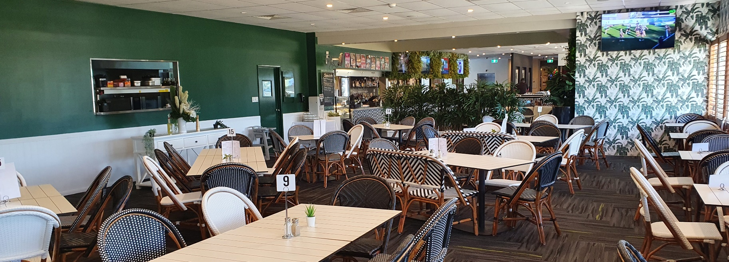
Platters*

Hot Seafood Platter (I) $170
A seafood feast featuring 1kg of salt & pepper calamari, 15 beer-battered prawns, 12 battered flathead fillets, & 1kg of chips, served with tartare sauce, homemade seafood sauce, & lemon wedges

Mixed Wrap Platter $120
Assortment of mixed fresh wraps (20 half wrap Pieces)

Mixed Sandwich Platter¹ $110
Assortment of mixed fresh sandwiches 40 triangles)

Pizza Platters¹ $110
Four delicious pizza varieties: Hawaiian, Carnivore, BBQ Chicken, & Vegetarian

American Platter $150
A delicious combo of 600g pork ribs, 8 Southwest chicken tenders, 8 mozzarella cheese sticks, ½ kilo of crispy skin chicken wings, 8 crispy potato skins, & 1kg crinkle-cut chips, served with ranch & chipotle Southwest dipping sauces

Aussie Platter $130
Packed with the crowd-favourite 8 party pies, 8 sausage rolls, 1kg of seasoned wedges, 8 chicken nuggets, 4 Chiko rolls, and 8 mini Dagwood dogs, served with tomato & BBQ sauce

Chicken Wings Platter $110
Enjoy 2.5kg of crispy skin chicken wings, served with three delicious side sauces: American smokey BBQ, ranch dipping sauce, & Louisiana hot sauce

Gourmet Slider Platter $140
Fresh slider buns (30), with 15 crumbed chicken parmi & 15 grilled beef patties, served with lettuce, tomato, onion, beetroot, and cheese, topped with burger sauce.

Asian Platter $120
Consists of 8 BBQ pork buns, 8 assorted dim sims, 8 samosas, 8 vegetarian spring rolls, 8 prawn toasts (I), 8 chicken satay skewers, and 8 mini curry puffs, served with wasabi and Asian chili sauce

Profiterole Platter $100
Assortment of profiteroles (30 pieces)

Kids Platter $100
Served with Chicken nuggets, mini fish bites & plenty of chips, served with tomato & BBQ sauce

Gluten free plate $25 pp
Hot gluten-free options available, our chef will recommend customisations

*No leftover food from platters is permitted to be taken off the premises
¹Platters can be adjusted slightly/items substituted to cater for Halal requirements.
Outside food is not permitted on the premises
BYO alcohol and non-alcoholic beverages are strictly prohibited
Seafood Origin: A=Australian I=Imported M=Mixed

Terms and Conditions
Beenleigh Bowls Club will herein be referred to as “the Club”.

EVENT ELIGIBILITY GUIDELINES
The Club does not host functions for birthday celebrations under 21 years of age, including 18th birthdays and other milestone celebrations. This policy is in place to ensure a safe and enjoyable environment for all guests

CONFIRMATION & DEPOSIT
This form must be signed, and deposit paid, within fourteen (14) days of making your booking. Tentative bookings will be held for a period of fourteen (14) days.
A deposit of the agreed room hire is required to secure the room confirming the room is booked.
If your function/event is cancelled less than (7) Days prior to event date, this deposit will be non-refundable. Management also reserves the right to cancel any function where upon the deposit is not received within the stipulated time frame.

FINAL NUMBERS
The function organisers must advise the guaranteed number of guests attending the function fourteen (14) days prior to function date. Age & number of children attending must also be supplied at this time – should special kids’ meals be ordered. Children must always be supervised whilst on Club premises.

Any reduction after this date will be charged at previously guaranteed numbers.

FINAL BALANCE
In addition to final numbers, the outstanding balance is required seven (7) days prior to function date. *Additional conditions may apply to bookings made two (2) weeks or less in advance*

CANCELLATION
In the event of a cancellation of a confirmed function all monies paid are refundable, if we are closed due to government mandate closure of Hospitality venues, or more than 14 notice is given.

START/FINISH TIME
The function organisers agree to begin and vacate the designated space at the scheduled time. The Club’s operating hours are 9am till midnight 7 days, with all functions to finish by 11.30pm and no later. Room hire covers 5 hours of hire for any function, if longer is required their maybe further costs for room hire. Patrons are welcomed to bring their own decorations for their event but must remove at the end of the event or a charge will be issued.

COMPLIANCE
It is understood that the patron will conduct their function in an orderly manner and in full compliance with Club Management and all applicable laws. This includes, but is not limited to, liquor licensing laws, minors, non-smoking and responsible service of alcohol.

SIGNAGE AND DISPLAY
There is no signage and display to be nailed, screwed of fixed in any way to any wall, door, or other part of the building unless the Club grants prior permission in writing.

OUTSIDE CATERERS
No food or beverages of any kind may be brought into the Club for consumption at the function by the organiser, patrons, or guests unless prior approval has been granted by Club Management

INSURANCE
The Club will not accept responsibility for damage or loss of merchandise left in the Club prior, during or after a function. The organiser of the function must arrange their own insurance/security if required.

FIRE SAFETY
The use of compressed gas, flammable liquid/gas, heaters, lamps, lanterns, candles, and other heat producing devices are forbidden in the Club. The above devices if needed by the function must have prior approval of the Club. It is also a requirement that lights must remain on for the duration of a function as it a risk to staff and guests.

ELECTRICAL
Any use of electrical equipment beyond what is supplied by the Club will incur the cost of installation or rewiring reconnection.

CONFETTI
Confetti or rice grains are not permitted inside the Club or the grounds.

CLEANING
General cleaning is included in the hire of any space within the Club, however, if cleaning requirements are considered excessive at completion of any function, additional cleaning charges will be incurred. This will be quoted upon by independent contractors to be charged to the function organiser.

SECURITY
The Club reserves the right to exclude or eject all objectionable person(s) from the function or Club premises without liability.

Some events may require security at the Club's discretion, with the cost of $75 per hour (minimum 4 hours) charged to the function organiser

UNFORESEEN CIRCUMSTANCE / ACT OF GOD
The Club does not accept liability in the event of any natural disaster, labour dispute, transportation, strike, picketing, power failure, fire, or other unforeseen circumstance beyond the Club's control.

MINORS
The Club does not accept responsibility for guests under the age of eighteen years. All minors attending functions at the Club must be accompanied by a responsible adult and under no circumstance may they be served or provided alcohol.

ENTERTAINMENT
Music and entertainment are at discretion of the Club management and will be always controlled by the Club management in accordance with State and Federal legislation.

I understand by filling the forms below, I agree to the terms and conditions listed above by Beenleigh Bowls Club and its representative.
CONTACT NAME: _____________________________________________________
CONTACT NUMBER: __________________________________________________
SIGNED: _____________________________________ DATE: __________________

